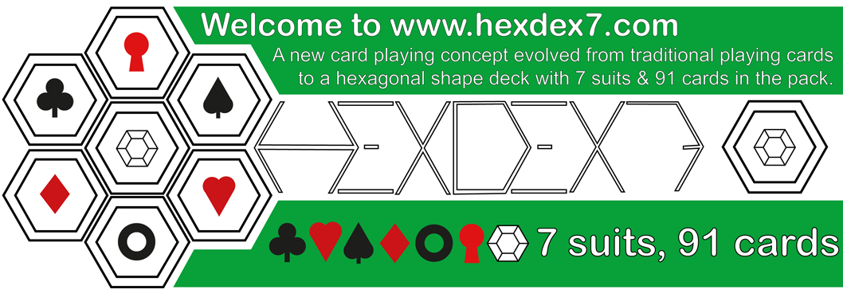
A new take on traditional playing cards called HexDex7, it's 7 suits on a hex shaped deck (Hearts, clubs, diamonds, spades, rings, keys and gems.) A new style of playing cards that are designed for a poker game called 'HexDex7 poker' based on 'Southern Cross poker' but with a hex 7 card layout in place of the cross, instructions below, with up to 12 players it can be a high hands and high stakes game. Offering a free hex deck to print off the site, below, cut out and start evolving your own choice of subject matter and imagery. It is the evolution of standard playing cards to the hexdex7 format that I'm trying to establish, with up to 3 extra suits for game play. Hexdex7 poker is the first new card game to come out of the 7 suit format, many new games to follow shortly, or you can remove the 3 new suits and play with a standard format deck.
email: eddycrowley71@gmail.com

